LET’S TACO ABOUT THE PLOT

Background
The plot is the most important part of a story because it holds everything together—it is the structure, the stuff that actually happens. Like the taco shell, it might not be the best part, but it is the most necessary.

How to Plot Your Story

Step 1: Create a 1-sentence summary by answering The Big Three:
  - Who is your main character?
  - What do they want?
  - How are they going to get it?

Example from DEATHWATCH by Robb White: Ben, a college student and outdoor guide (Who), must rely on his survival skills and knowledge of geography (How) to escape the Mojave Desert after a rich client, Madec, tries to murder him in order to cover up a fatal hunting accident (What).

Step 2: Put your 1-sentence summary on a plot diagram
What does Ben want? To escape the desert from the murderous Madec
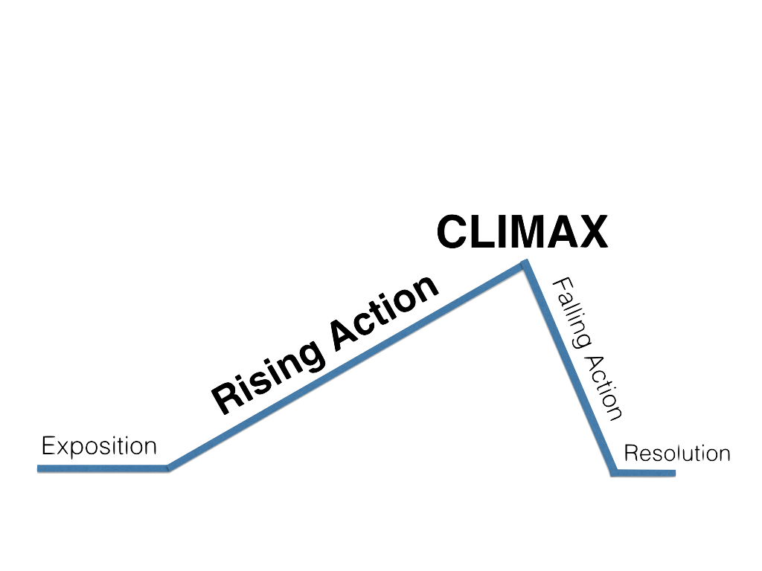
Step 3: Widen the plot with a short synopsis, a 2-4-page summary
- Includes more detailed scenes, specifically the initial incident (event that launches the character into the rising action) and the story’s climax (when the conflict is resolved)
- Characters and themes begin to emerge
- Does not need to include EVERY scene or detail
- Helps you see any problems with the story and why

Who is Ben?
A college-age student and outdoor guide
How will Ben get what he wants? By using his survival skills and knowledge of geography
OTHER PLOTTING TIPS
- Create tension by adding scenes that put the main character’s goal/quest in danger. This engages the reader by making them anxious and curious.
    - Example from DEATHWATCH: Ben nearly dies from sun exposure and dehydration during his escape from the desert. Also, there is always the threat of Madec outright shooting him with his hunting rifle.
- Always go back to the story arc—your 1-sentence summary that is the story’s main highway. Ask, “Is this scene moving the story forward along the arc?”

Activity: Choose one of your favorite books or movies and taco about the plot.

Book or Movie:

The Big Three:
- Who is the main character(s)?

- What do they want?

- How do they get it?

1-Sentence Summary:

Add the following elements to the plot diagram: Who, the initial incident, several events from the How, the climax (What), and the resolution—how the story ends.

